Ex.No:1(a) Reverse a given Number
Aim:-
To Write a java program to Reverse a given string

Algorithm:-

Step 1: Start the program

Step 2:Assign a string to a String variable

Step 3:Calculate the string length

Step 4:using for loop print tht string in reverse order using the function charAt()

Step 5:Stop the process

Coding:-

public class rev
{
public static void main(String[]args)
{
String str="HELLO";
System.out.println(ReverseString.reverseIt(str));
}
}
class ReverseString
{
public static String reverseIt(String source)
{
int i,len=source.length();
StringBuffer dest=new StringBuffer(len);
for(i=(len-1);i>=0;i--)
dest.append(source.charAt(i));
return dest.toString();
}
}

Output:
E:\javapgm>java rev
OLLEH

Result:-
Thus the java program to Reverse a given string was executed Successfully.

Ex.No:1(b)
Product of a given Digit.

Aim:-
To Write a java program to Write a program to find sum and product of a given Digit.

Algorithm:-

Step 1: Start the program

Step 2:Get the number from the user

Step 3:Calculate the sum of given number

Step 4: Calculate the product of given number

Step 5:Stop the process

Coding:-

import java.util.Scanner;
class sumandproduct
{
public static void main(String args[])
{
int n,s=0,d=0,p=1;
System.out.println("Enter a number");
Scanner input=new Scanner(System.in);
n=input.nextInt();
while(n>0)
{
d=n%10;
s=s+d;
if(d!=0)
p=p*d;
n=n/10;
}
System.out.println("Sum is"+s);
System.out.println("Product is"+p);
}
}

Output:
E:\javapgm>java sumandproduct
Enter a number
431
Sum is=8
Product is =12

Result:-
Thus the java program to find sum and product of a given Digit was executed Successfully.

Ex.No:2(a) Display Invert Triangle

Aim:-
To Write a java program to Display Invert Triangle
Algorithm:-
Step 1: Start the program

Step 2: assign the for loop

Step 3: print the character

Step 4: display the output

Step 5: Stop the process

Coding:-
import java.util.Scanner;
class inversetriangle
{
public static void main(String args[])
{
int j;
int i=1;
i=11;
while(i>=1)
{
for(j=1;j<=i;j++)
System.out.print("*");
i=i-2;
System.out.println( );
}
System.out.println("Inverse Of Tringle");
while(i<=11)
{
for(j=1;j<=i;j++)
System.out.print("*");
i=i+2;
System.out.println();
}
}
}

Output:
E:\javapgm>java inversetriangle
***********
*********
*******
*****
***
*
Inverse Of Tringle

*
***
*****
*******
*********
***********

Result:-
Thus the java program to Display Invert Triangle was executed Successfully.

Ex.No:2 (b) Find whether number is Prime or Not

Aim:-
To Write a java program to Find whether number is Prime or Not

Algorithm:-

Step 1: Start the program

Step 2: get a number from user

Step 3: check the condition if(x%i==0)

Step 4:if true means print Not a Prime Number else print Prime Number

Step 5:Stop the process

Coding:-

import java.util.Scanner;
class oddeven
{
public static void main(String args[])
{
int x;
System.out.println("Enter a number");
Scanner input = new Scanner(System.in);
x=input.nextInt();
for(int i=2;i<=x/2;i++)
{
if(x%i==0)
{
System.out.println("even number");
return;
}
System.out.println("odd Number");
return;
}
}
}

Output:
E:\javapgm>java oddeven
Enter a number
25
odd Number

E:\javapgm>java oddeven
Enter a number
50
even number

Result:-
Thus the java program to Find whether number is Prime or Not
was executed Successfully.

Ex.No:3 Abstract classes

Aim:-
To Write a java program for Abstract classes

Algorithm:-

Step 1: Start the program

Step 2: declare abstract class and methods

Step 3:define in another class

Step 4: print the statement

Step 5:Stop the process

Coding:-

abstract class Abstract
{
abstract void callme();
void callmetoo()
{
System.out.println("This is a concrete method");
}
}
class B extends Abstract
{
void callme()
{
System.out.println("B's implementation of callme");
}
}
class AbstractDemo
{
public static void main(String args[])
{
B b= new B();
b.callme();
b.callmetoo();
}
}

Output:
E:\javapgm>java AbstractDemo
B's implementation of callme
This is a concrete method

Result:-
Thus the java program Abstract classes was executed Successfully .

Ex.No:4 To implement java program for Inheritance

Aim:-
To Write a java program to implement the inheritance

Algorithm:-

Step 1: Start the program

Step 2:Get name,age,rno from user

Step 3: calculate avg,total

Step 4:print the mark statement

Step 5:Stop the process

Coding:-

import java.io.*;
class stud
{
String name;
int age,rno;
void stu(String n,int a,int r)
{
name=n;
age=a;
rno=r;
}
void putstud()
{
System.out.println("STUDENT INFORMATION");
System.out.println("NAME: "+name);
System.out.println("AGE:"+age);
System.out.println("ROLL NO: "+rno);
}
}
class mark extends stud
{
int m1,m2,m3;
void mar(int mk1,int mk2,int mk3)
{
m1=mk1;
m2=mk2;
m3=mk3;
}
void putmark()
{
System.out.println("STUDENT MARK INFORMATION");
System.out.println("OOPS : "+m1);
System.out.println("JAVA :"+m2);
System.out.println("C++ : "+m3);
}
}
class total extends mark
{
float tot,avg;
void tot()
{
tot =m1+m2+m3;
avg=tot/3;
System.out.println("TOTAL: "+tot);
System.out.println("AVERAGE:"+avg);
}
}
class inheritance
{
public static void main(String arg[])
{
total t=new total();
t.stu("Karthik",19,35);
t.mar(100,99,99);
t.putstud();
t.putmark();
t.tot();
}
}

Output:
E:\javapgm>java inheritance
STUDENT INFORMATION
NAME: Karthik
AGE:19
ROLL NO: 35
STUDENT MARK INFORMATION
OOPS : 100
JAVA :99
C++ : 99
TOTAL: 298.0
AVERAGE:99.333336

Result:-
Thus the java program for Inheritance was executed Successfully.

Ex.No:5 To implement java program for Interfaces

Aim:-
To write a java program to implement the interface.
Algorithm:-

Step 1: Start the program

Step 2:Declare the base class then using the keyword “extends” declare the derived base class

Step 3:inherite another class property

Step 4:display the output

Step 5:Stop the process

Coding:-

class library
{
int bookno;
void getbookno(int b)
{
bookno=b;
}
void disp1()
{
System.out.println("Book No:"+bookno);
}
}
class book extends library
{
String s1,s2;
void getinfo(String authour,String title)
{
s1=authour;
s2=title;
}
void disp2()
{
System.out.println("Authour:"+s1);
System.out.println("Title:"+s2);
}
}
interface language
{
String i="English";
void disp3();
}
interface price
{
int j=2000;
void disp5();
}
class issue extends book implements language,price
{
public void disp3()
{
System.out.println("Book written in:"+i);
}
public void disp5()
{
System.out.println("Book price:"+j);
}
void disp4()
{
System.out.println("ISSUE");
disp1();
disp2();
disp3();
disp5();
}
}
class interfacing
{
public static void main(String args[])
{
issue i=new issue();
i.getbookno(100);
i.getinfo("karthik","Java:the book of reference ");
i.disp4();
}
}

Output:
E:\javapgm>java interfacing
ISSUE
Book No:100
Authour:karthik
Title:Java:the book of reference
Book written in:English
Book price:2000

Result:-
Thus the java program for Interface was executed Successfully.

Ex.No:6 Event handling using applets(keyboard)

Aim:-
To write a java program to implement Event handling using applets(keyboard)

Algorithm:-
Step 1: Start the program

Step 2: create class with extend the applet property

Step 3:generate key event

Step 4:display the output

Step 5:Stop the process

Coding:-
import java.awt.*;
import java.applet.*;
/*
<applet code="SimpleKey" width=300 height=100>
</applet>
*/

public class SimpleKey extends Applet{
String msg = "";
public boolean keyDown(Event evtObj, int key) {

if((char)key=='m') msg="Good Morning";
if((char)key=='e') msg="Good Evening";
if((char)key=='n') msg="Good Night";
repaint();
showStatus("Key Down");
return true;
}

public boolean keyUp(Event evtObj, int key) {
showStatus("Key Up");

return true;
}

public void paint(Graphics g)
{
g.setFont(new Font("Times New Roman",Font.BOLD,20));
g.drawString("m:Good Morning", 60, 20);
g.drawString("e:Good Evening", 60, 40);
g.drawString("n:Good Night", 60, 60);
g.drawString(msg, 60, 80);

}
}

Output:
E:\javapgm>appletviewer SimpleKey.java

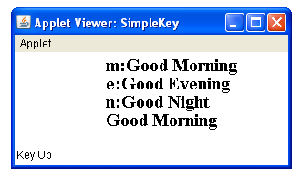

Result:-
Thus the java program for Event handling using applets was executed Successfully

Ex.No:7 Event handling using applets(mouse)

Aim:-
To write a java program to implement Event handling using applets(mouse)

Algorithm:-
Step 1: Start the program
Step 2: create class with extend the applet property

Step 3:generate mouse event

Step 4:display the output

Step 5:Stop the process

Coding:-

import java.awt.*;
import java.applet.*;
/*
<applet code="Mouse" width=300 height=100>
</applet>
*/

public class Mouse extends Applet
{
String msg = "";
int mouseX = 0, mouseY = 0;

public boolean mouseDown(Event evtObj, int x, int y)
{
mouseX = x;
mouseY = y;
msg = "Mouse Pressed";
repaint();

return true;
}
public void init()
{
setBackground(Color.pink);
}

public boolean mouseUp(Event evtObj, int x, int y)
{

mouseX = x;
mouseY = y;
msg = "Mouse Released";
repaint();

return true;
}

public boolean mouseMove(Event evtObj, int x, int y) {

showStatus("Moving mouse at " + x + ", " + y);

return true;
}

public boolean mouseDrag(Event evtObj, int x, int y) {

mouseX = x;
mouseY = y;
msg = "Dragging Mouse";
showStatus("Dragging mouse at " + x + ", " + y);
repaint();

return true;
}

public boolean mouseEnter(Event evtObj, int x, int y) {

mouseX = 10;
mouseY = 50;
msg = "Mouse just entered in to the window.";
repaint();

return true;
}

public boolean mouseExit(Event evtObj, int x, int y) {

mouseX = 10;
mouseY = 50;
msg = "Mouse just left out from window.";
repaint();

return true;
}
public void paint(Graphics g)
{ g.setFont(new Font("Times New Roman",Font.BOLD,40));
g.setColor(Color.blue);
g.drawString(msg, mouseX, mouseY);
}
}

Output:
E:\javapgm>appletviewer Mouse.java

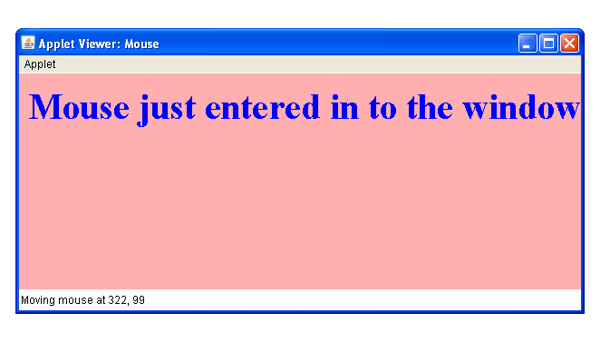

Result:-
Thus the java program for Event handling using applets was executed Successfully

Ex.No:8 Threads(Extending thread class method)
Aim:-
To write a java program to implement thread using Extending thread class method.
Algorithm:-

Step 1: Start the program

Step 2: create thread for class

Step 3:allocate process for thread

Step 4:run the process

Step 5:Stop the process

Coding:-

import java.io.*;
import java.awt.*;
class table1 extends Thread
{
public void run()
{
System.out.println("Thread Started");
for(int i=1;i<=3;i++)
{int k=i+5;
System.out.println(i+"+"+"5"+"="+k);
}
System.out.println("Thread Exits");
}}

class simplethread
{
public static void main(String args[])
{
table1 t1=new table1();
System.out.println("$$$$ Thread $$$$");
t1.start();
}}

Output:
E:\javapgm>java simplethread
$$$$ Thread $$$$
Thread Started
1+5=6
2+5=7
3+5=8
Thread Exits
Result:-
Thus the java program for implementating threads using Extending thread class method was done successfully.

Ex.No:9 Threads(using Runnable)

Aim:-
To write a java program to implement thread using Runnable method.
Algorithm:-

Step 1: Start the program

Step 2: create thread for class

Step 3:allocate process for thread

Step 4:run the process

Step 5:Stop the process

Coding:-

import java.io.*;
import java.awt.*;

class MyThread1 implements Runnable{
Thread t;
MyThread1(String s) {
t=new Thread(this,s);
t.start();
}
public void run() {
for(int i=0;i<5;i++) {
System.out.println("Thread Name :"+Thread.currentThread().getName());
try {
Thread.sleep(1000);
}catch(Exception e){}
}
}
}
public class RunnableThread1{
public static void main(String args[]) {
System.out.println("Thread Name :"+Thread.currentThread().getName());
MyThread1 m1=new MyThread1("My Thread 1");
MyThread1 m2=new MyThread1("My Thread 2");
}
}

Output:

E:\javapgm>java RunnableThread
Thread Name :main
Thread Name :My Thread 1
Thread Name :My Thread 2
Thread Name :My Thread 2
Thread Name :My Thread 1
Thread Name :My Thread 2
Thread Name :My Thread 1
Thread Name :My Thread 1
Thread Name :My Thread 2
Thread Name :My Thread 2
Thread Name :My Thread 1

Result:-
Thus the java program for to implement multiple Threads was executed Successfully

Ex.No:10 Swing

Aim:-
To write a java program to get and print the user information using swing.
Algorithm:-
Step 1: Start the program
Step 2: create swing for applet

Step 3:extend the Japplet class

Step 4:run the swing applet

Step 5:Stop the process

Coding:-

import java.awt.*;
import java.awt.event.*;
import javax.swing.*;
import javax.swing.JButton.*;
/*<applet code="multilinetext"width=300 height=100>
</applet>*/
public class multilinetext extends JApplet
{
JTextField name,age,qual;
JTextArea addrs;
Label n,a,q,ads;
JButton my;
String na="",s="",c="",ad="";
public void init()
{
Container c=getContentPane();
c.setLayout(null);
c.setBackground(Color.pink);
n=new Label("NAME:",Label.LEFT);
a=new Label("AGE:",Label.LEFT);
q=new Label("QUALIFICATION:",Label.LEFT);
ads=new Label("ADDRESS:",Label.LEFT);
my=new JButton("my details");
name=new JTextField();
age=new JTextField();
qual=new JTextField();
addrs=new JTextArea(3,2);
n.setBounds(50,50,100,25);
a.setBounds(50,75,100,25);
q.setBounds(50,100,100,25);
ads.setBounds(50,125,100,25);
name.setBounds(200,50,200,25);
age.setBounds(200,75,200,25);
qual.setBounds(200,100,200,25);
addrs.setBounds(200,125,200,75);
my.setBounds(200,200,200,25);

c.add(n);
c.add(a);
c.add(q);
c.add(ads);
c.add(my);
c.add(name);
c.add(age);
c.add(qual);
c.add(addrs);
my.addActionListener(new ButtonHandler());
repaint();
}
public void paint(Graphics g)
{
Font f=new Font("arial",Font.BOLD/Font.ITALIC,30);
g.setFont(new Font("Times New Roman",Font.BOLD,18));
g.drawString(na,30,250);
g.drawString(s,30,275);
g.drawString(c,30,300);
g.drawString(ad,30,325);
}
class ButtonHandler implements ActionListener
{
public void actionPerformed(ActionEvent ae)
{
String arg=ae.getActionCommand();
if(arg.equals("my details"))
{
na=name.getText();
s=age.getText();
c=qual.getText();
ad=addrs.getText();
repaint();
}}}}

Output:
E:\javapgm>appletviewer multilinetext.java
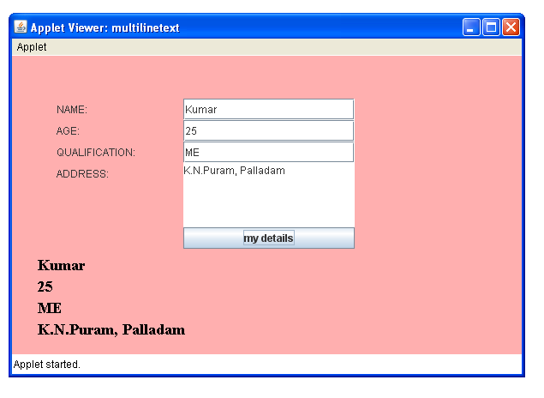

Result:-
Thus the java program for swing was executed Successfully

Ex.No:11(a) File handling (copy Bytes)

Aim:-
To write a java program for File handling using copy Bytes.

Algorithm:-
Step 1: Start the program

Step 2: Read the input string from file

Step 3: copy the content

Step 4:close the file

Step 5:Stop the process

Coding:-
import java.io.FileInputStream;
import java.io.FileOutputStream;
import java.io.IOException;
public class copybytes
{
public static void main(String[]args)throws Exception
{
FileInputStream in=null;
FileOutputStream out=null;
try{
in=new FileInputStream("xanadle.txt");
out=new FileOutputStream("outgain.txt");
int c;
while((c=in.read())!=-1){
out.write(c);
}
}
finally
{
if(in!=null){
in.close();
}
if(out!=null);
out.close();
}
}}

Output:
E:\javapgm>javac copybytes.java

E:\javapgm>java copybytes

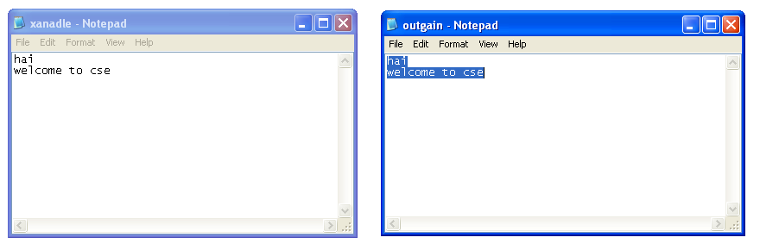
Result:-
Thus the java program for copy bytes was executed Successfull

Ex.No:11( b ) File handling (Using Random Access)

Aim:-
To write a java program for File handling using Random Access.

Algorithm:-

Step 1: Start the program

Step 2: Read the input string from file

Step 3: access the content

Step 4:close the file

Step 5:Stop the process

Coding:-

import java.io.*;
class RandomAccess
{
public static void main(String args[])
{
RandomAccessFile rFile;
try{
rFile=new RandomAccessFile("city.txt","rw");
rFile.seek(rFile.length());
rFile.writeBytes("MUMBAI\n");
rFile.close();
}
catch(IOException e){
System.out.println(e);
}}}

Output:
E:\javapgm>javac RandomAccess.java

E:\javapgm>java RandomAccess

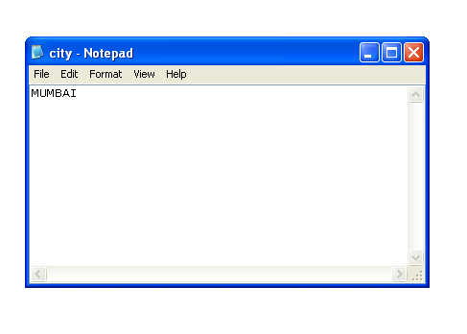

Result:-
Thus the java program for file handling using RandomAccess was executed Successfully.

Ex.No:11(c ) File handling(using File Reader)

Aim:-
To write a java program for File handling using File Reader.
Algorithm:-

Step 1: Start the program

Step 2: Read the input string from file

Step 3: Read the content

Step 4:close the file

Step 5:Stop the process

Coding:-

import java.io.*;
class frd
{
public static void main(String args[])throws IOException
{
FileReader fr=new FileReader("karthik.txt");
BufferedReader br=new BufferedReader(fr);
String s;
while((s=br.readLine())!=null)
{
System.out.println(s);
}
fr.close();
}
}

Output:

E:\javapgm>java frd
welcome
cse
this is simple java program

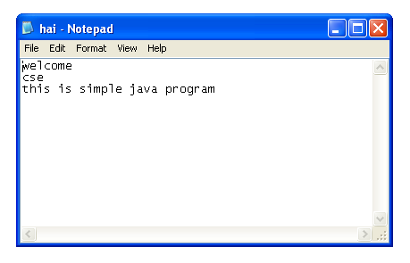

Result:-
Thus the java program for file handling using File Reader was executed Successfully

Ex.No:11(d ) File handling (using File Writer)

Aim:-
To write a java program for File handling using File Writer
Algorithm:-

Step 1: Start the program

Step 2: Read the input string from file

Step 3: write the content

Step 4:close the file

Step 5:Stop the process

Coding:-

import java.io.*;
class RandomAccess
{
public static void main(String args[])
{
RandomAccessFile rFile;
try{
rFile=new RandomAccessFile("city.txt","rw");
rFile.seek(rFile.length());
rFile.writeBytes("MUMBAI\n");
rFile.close();
}
catch(IOException e){
System.out.println(e);
}}}

Result:-
Thus the java program for FileWriter was executed Successfully

Ex.No:12 Database applications using JDBC

Aim:-
To implement java program for Database applications (JDBC)

Algorithm:-

Step 1: Start the program

Step 2:Initialize the driver name,url,username,password and connection string for JDBC connectivity with Oracle

Step 3:create the employee table and insert the values

Step 4:Display the employee table and close the database connection.

Step 5:Stop the process

Coding:-

// CREATING EMPLOYEE TABLE USING JDBC
import java.sql.Connection;
import java.sql.Statement;
import java.sql.DriverManager;
import java.sql.SQLException;

public class MainClass {

private static final String EMPLOYEE_TABLE = "create table MyEmployees3 ( "
+ " id INT PRIMARY KEY, firstName VARCHAR(20), lastName VARCHAR(20), "
+ " title VARCHAR(20), salary INT " + ")";

public static Connection getConnection() throws ClassNotFoundException, SQLException {
String driver = "sun.jdbc.odbc.JdbcOdbcDriver";
String url = "jdbc:odbc:sss";
String username = "scott";
String password = "tiger";
Class.forName(driver);
Connection conn = DriverManager.getConnection(url, username, password);
return conn;
}

public static void main(String args[]) {
Connection conn = null;
Statement stmt = null;
try {
conn = getConnection();
stmt = conn.createStatement();
stmt.executeUpdate(EMPLOYEE_TABLE);
stmt.executeUpdate("insert into MyEmployees3(id, firstName,lastName,title,salary) values(100,

'mani','s','cse',2345)");
stmt.executeUpdate("insert into MyEmployees3(id, firstName,lastName,title,salary) values(200,

'suresh','s','eee',3546)");
System.out.println("CreateEmployeeTableOracle: main(): table created.");
} catch (ClassNotFoundException e) {
System.out.println("error: failed to load Oracle driver.");
e.printStackTrace();
} catch (SQLException e) {
System.out.println("error: failed to create a connection object.");
e.printStackTrace();
} catch (Exception e) {
System.out.println("other error:");
e.printStackTrace();
} finally {
try {
stmt.close();
conn.close();
} catch (Exception e) {
}
}
}
}

Result:
Thus the JDBC program for employee database was executed successfully.

